BÀI TẬP
Môn TKPMHDT
---

Một số bài tập về Design Patterns
- Với mỗi lược đồ lớp dưới đây, hãy cho biết mẫu thiết kế nào được áp dụng và nêu vai trò của mỗi lớp dựa trên cấu trúc của mẫu thiết kế đó.
  - Lược đồ 1:

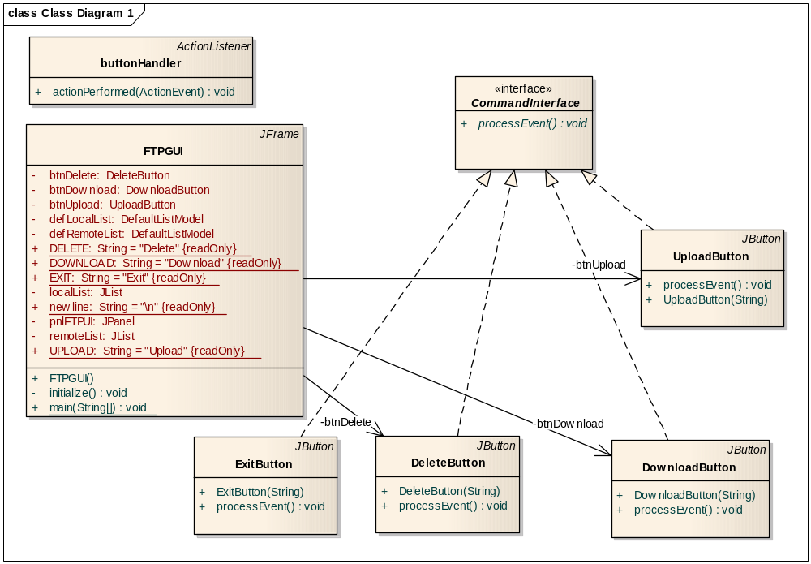

  - Lược đồ 2:

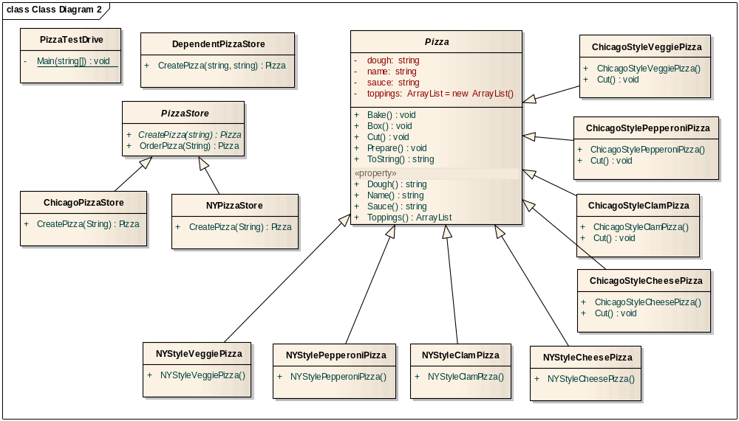

  - Lược đồ 3:

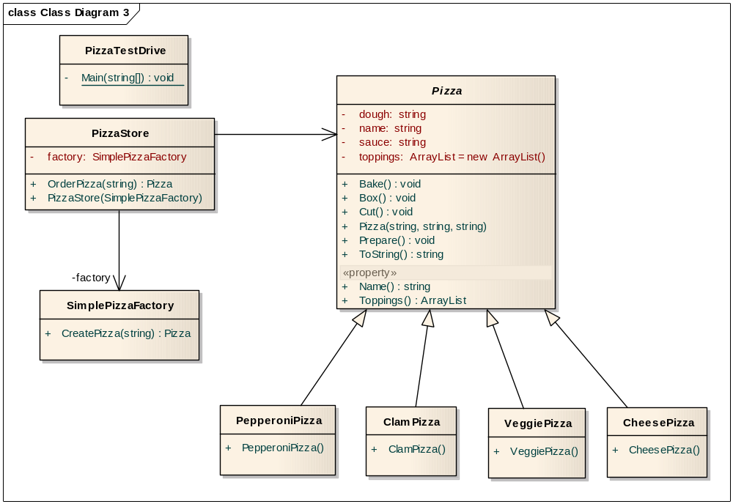

  - Lược đồ 4:

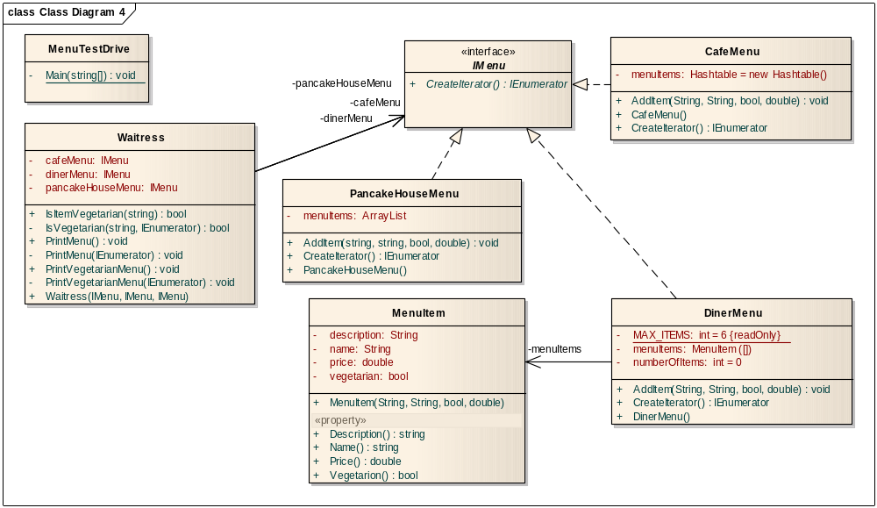

  - Lược đồ 5:

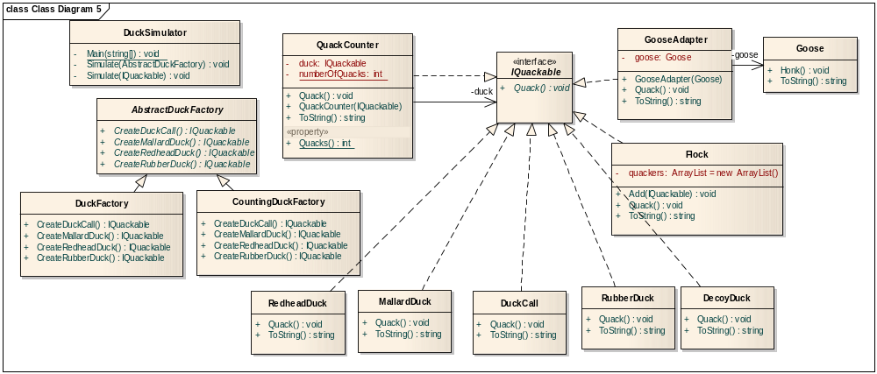

- Với mỗi đoạn code dưới đây, hãy cho biết mẫu thiết kế nào được áp dụng và nêu vai trò của từng lớp dựa trên cấu trúc của mẫu thiết kế đó.
Lưu ý: hạn chế dùng EA để phát sinh sơ đồ lớp. Chỉ nên sử dụng để kiểm tra lại kết quả mà thôi.
  - Chương trình 1:

using System;

namespace Ducks1
{
class DuckSimulator
{
static void Main(string[] args)
{
DuckSimulator simulator = new DuckSimulator();
simulator.Simulate();

// Wait for user
Console.Read();
}

void Simulate()
{
IQuackable mallardDuck = new MallardDuck();
IQuackable redheadDuck = new RedheadDuck();
IQuackable duckCall = new DuckCall();
IQuackable rubberDuck = new RubberDuck();

Console.WriteLine("Duck Simulator");

Simulate(mallardDuck);
Simulate(redheadDuck);
Simulate(duckCall);
Simulate(rubberDuck);
}

void Simulate(IQuackable duck)
{
duck.Quack();
}
}

#region Duck

public interface IQuackable
{
void Quack();
}

public class RubberDuck : IQuackable
{
public void Quack()
{
Console.WriteLine("Squeak");
}
}

public class RedheadDuck : IQuackable
{
public void Quack()
{
Console.WriteLine("Quack");
}
}

public class MallardDuck : IQuackable
{
public void Quack()
{
Console.WriteLine("Quack");
}
}

public class DuckCall : IQuackable
{
public void Quack()
{
Console.WriteLine("Kwak");
}
}

public class DecoyDuck : IQuackable
{
public void Quack()
{
Console.WriteLine("<< Silence >>");
}
}

#endregion
}

  - Chương trình 2:

using System;

namespace Ducks2
{
class DuckSimulator
{
static void Main(string[] args)
{
DuckSimulator simulator = new DuckSimulator();
simulator.Simulate();

// Wait for user
Console.Read();
}

void Simulate()
{
IQuackable mallardDuck = new MallardDuck();
IQuackable redheadDuck = new RedheadDuck();
IQuackable duckCall = new DuckCall();
IQuackable rubberDuck = new RubberDuck();
IQuackable gooseDuck = new GooseAdapter(new Goose());

Console.WriteLine("Duck Simulator: With Goose Adapter");

Simulate(mallardDuck);
Simulate(redheadDuck);
Simulate(duckCall);
Simulate(rubberDuck);
Simulate(gooseDuck);
}

void Simulate(IQuackable duck)
{
duck.Quack();
}
}

#region Ducks

public interface IQuackable
{
void Quack();
}

public class DecoyDuck : IQuackable
{
public void Quack()
{
Console.WriteLine("<< Silence >>");
}
}

public class RedheadDuck : IQuackable
{
public void Quack()
{
Console.WriteLine("Quack");
}
}

public class MallardDuck : IQuackable
{
public void Quack()
{
Console.WriteLine("Quack");
}
}

public class RubberDuck : IQuackable
{
public void Quack()
{
Console.WriteLine("Squeak");
}
}

public class DuckCall : IQuackable
{
public void Quack()
{
Console.WriteLine("Kwak");
}
}

#endregion

#region Goose

public class GooseAdapter : IQuackable
{
Goose goose;

// Constructor
public GooseAdapter(Goose goose)
{
this.goose = goose;
}

public void Quack()
{
goose.Honk();
}

public override string ToString()
{
return "Goose pretending to be a Duck";
}
}

public class Goose
{
public void Honk()
{
Console.WriteLine("Honk");
}
}

#endregion
}

  - Chương trình 3:

using System;

namespace Ducks3
{
class DuckSimulator
{
static void Main(string[] args)
{
DuckSimulator simulator = new DuckSimulator();
simulator.Simulate();
}

void Simulate()
{
IQuackable mallardDuck = new QuackCounter(new MallardDuck());
IQuackable redheadDuck = new QuackCounter(new RedheadDuck());
IQuackable duckCall = new QuackCounter(new DuckCall());
IQuackable rubberDuck = new QuackCounter(new RubberDuck());
IQuackable gooseDuck = new GooseAdapter(new Goose());

Console.WriteLine("Duck Simulator: With Decorator");

Simulate(mallardDuck);
Simulate(redheadDuck);
Simulate(duckCall);
Simulate(rubberDuck);
Simulate(gooseDuck);

Console.WriteLine("The ducks quacked " +
QuackCounter.Quacks + " times");

// Wait for user
Console.Read();
}

void Simulate(IQuackable duck)
{
duck.Quack();
}
}

#region Ducks

public interface IQuackable
{
void Quack();
}

public class RubberDuck : IQuackable
{
public void Quack()
{
Console.WriteLine("Squeak");
}

public override string ToString()
{
return "Rubber Duck";
}
}

public class RedheadDuck : IQuackable
{
public void Quack()
{
Console.WriteLine("Quack");
}
}

public class MallardDuck : IQuackable
{

public void Quack()
{
Console.WriteLine("Quack");
}

public override string ToString()
{
return "Mallard Duck";
}
}

public class DuckCall : IQuackable
{

public void Quack()
{
Console.WriteLine("Kwak");
}

public override string ToString()
{
return "Duck Call";
}
}

public class DecoyDuck : IQuackable
{

public void Quack()
{
Console.WriteLine("<< Silence >>");
}

public override string ToString()
{
return "Decoy Duck";
}
}

#endregion

#region QuackCounter

public class QuackCounter : IQuackable
{
IQuackable duck;
static int numberOfQuacks;

public QuackCounter(IQuackable duck)
{
this.duck = duck;
}

public void Quack()
{
duck.Quack();
numberOfQuacks++;
}

public static int Quacks
{
get{ return numberOfQuacks; }
}

public override string ToString()
{
return duck.ToString();
}
}

#endregion

#region Goose

public class GooseAdapter : IQuackable
{
Goose goose;

public GooseAdapter(Goose goose)
{
this.goose = goose;
}

public void Quack()
{
goose.Honk();
}

public override string ToString()
{
return "Goose pretending to be a Duck";
}
}

public class Goose
{
public void Honk()
{
Console.WriteLine("Honk");
}

public override string ToString()
{
return "Goose";
}
}
#endregion
}

  - Chương trình 4:

using System;

namespace Ducks4
{
class DuckSimulator
{
static void Main(string[] args)
{
DuckSimulator simulator = new DuckSimulator();
AbstractDuckFactory factory = new CountingDuckFactory();

simulator.Simulate(factory);

// Wait for user
Console.Read();
}

void Simulate(AbstractDuckFactory factory)
{
IQuackable mallardDuck = factory.CreateMallardDuck();
IQuackable redheadDuck = factory.CreateRedheadDuck();
IQuackable duckCall = factory.CreateDuckCall();
IQuackable rubberDuck = factory.CreateRubberDuck();
IQuackable gooseDuck = new GooseAdapter(new Goose());

Console.WriteLine("Duck Simulator: With Abstract Factory");

Simulate(mallardDuck);
Simulate(redheadDuck);
Simulate(duckCall);
Simulate(rubberDuck);
Simulate(gooseDuck);

Console.WriteLine("The ducks quacked " +
QuackCounter.Quacks + " times");
}

void Simulate(IQuackable duck)
{
duck.Quack();
}
}

#region Factory

public abstract class AbstractDuckFactory
{
public abstract IQuackable CreateMallardDuck();
public abstract IQuackable CreateRedheadDuck();
public abstract IQuackable CreateDuckCall();
public abstract IQuackable CreateRubberDuck();
}

public class DuckFactory : AbstractDuckFactory
{

public override IQuackable CreateMallardDuck()
{
return new MallardDuck();
}

public override IQuackable CreateRedheadDuck()
{
return new RedheadDuck();
}

public override IQuackable CreateDuckCall()
{
return new DuckCall();
}

public override IQuackable CreateRubberDuck()
{
return new RubberDuck();
}
}

public class CountingDuckFactory : AbstractDuckFactory
{

public override IQuackable CreateMallardDuck()
{
return new QuackCounter(new MallardDuck());
}

public override IQuackable CreateRedheadDuck()
{
return new QuackCounter(new RedheadDuck());
}

public override IQuackable CreateDuckCall()
{
return new QuackCounter(new DuckCall());
}

public override IQuackable CreateRubberDuck()
{
return new QuackCounter(new RubberDuck());
}
}
#endregion

#region Quack Counter

public class QuackCounter : IQuackable
{
IQuackable duck;
static int numberOfQuacks;

public QuackCounter(IQuackable duck)
{
this.duck = duck;
}

public void Quack()
{
duck.Quack();
numberOfQuacks++;
}

public static int Quacks
{
get{ return numberOfQuacks; }
}

public override string ToString()
{
return duck.ToString();
}
}

#endregion

#region Ducks

public interface IQuackable
{
void Quack();
}

public class RubberDuck : IQuackable
{

public void Quack()
{
Console.WriteLine("Squeak");
}

public override string ToString()
{
return "Rubber Duck";
}
}

public class RedheadDuck : IQuackable
{
public void Quack()
{
Console.WriteLine("Quack");
}
}

public class MallardDuck : IQuackable
{

public void Quack()
{
Console.WriteLine("Quack");
}

public override string ToString()
{
return "Mallard Duck";
}
}

public class DuckCall : IQuackable
{

public void Quack()
{
Console.WriteLine("Kwak");
}

public override string ToString()
{
return "Duck Call";
}
}

public class DecoyDuck : IQuackable
{

public void Quack()
{
Console.WriteLine("<< Silence >>");
}

public override string ToString()
{
return "Decoy Duck";
}
}

#endregion

#region Goose

public class GooseAdapter : IQuackable
{
Goose goose;

public GooseAdapter(Goose goose)
{
this.goose = goose;
}

public void Quack()
{
goose.Honk();
}

public override string ToString()
{
return "Goose pretending to be a Duck";
}
}

public class Goose
{
public void Honk()
{
Console.WriteLine("Honk");
}

public override string ToString()
{
return "Goose";
}
}
#endregion
}

  - Chương trình 5:

using System;
using System.Collections;

namespace Ducks5
{
class DuckSimulator
{
static void Main(string[] args)
{
AbstractDuckFactory factory = new CountingDuckFactory();

DuckSimulator simulator = new DuckSimulator();
simulator.Simulate(factory);

// Wait for user
Console.Read();
}

void Simulate(AbstractDuckFactory factory)
{
IQuackable redheadDuck = factory.CreateRedheadDuck();
IQuackable duckCall = factory.CreateDuckCall();
IQuackable rubberDuck = factory.CreateRubberDuck();
IQuackable gooseDuck = new GooseAdapter(new Goose());

Console.WriteLine("Duck Simulator: With Composite - Flocks");

Flock flockOfDucks = new Flock();

flockOfDucks.Add(redheadDuck);
flockOfDucks.Add(duckCall);
flockOfDucks.Add(rubberDuck);
flockOfDucks.Add(gooseDuck);

Flock flockOfMallards = new Flock();

IQuackable mallardOne = factory.CreateMallardDuck();
IQuackable mallardTwo = factory.CreateMallardDuck();
IQuackable mallardThree = factory.CreateMallardDuck();
IQuackable mallardFour = factory.CreateMallardDuck();

flockOfMallards.Add(mallardOne);
flockOfMallards.Add(mallardTwo);
flockOfMallards.Add(mallardThree);
flockOfMallards.Add(mallardFour);

flockOfDucks.Add(flockOfMallards);

Console.WriteLine("\nDuck Simulator: Whole Flock Simulation");
Simulate(flockOfDucks);

Console.WriteLine("\nDuck Simulator: Mallard Flock Simulation");
Simulate(flockOfMallards);

Console.WriteLine("\nThe ducks quacked " +
QuackCounter.Quacks + " times");
}

void Simulate(IQuackable duck)
{
duck.Quack();
}
}

#region Factory

public abstract class AbstractDuckFactory
{

public abstract IQuackable CreateMallardDuck();
public abstract IQuackable CreateRedheadDuck();
public abstract IQuackable CreateDuckCall();
public abstract IQuackable CreateRubberDuck();
}

public class DuckFactory : AbstractDuckFactory
{
public override IQuackable CreateMallardDuck()
{
return new MallardDuck();
}

public override IQuackable CreateRedheadDuck()
{
return new RedheadDuck();
}

public override IQuackable CreateDuckCall()
{
return new DuckCall();
}

public override IQuackable CreateRubberDuck()
{
return new RubberDuck();
}
}

public class CountingDuckFactory : AbstractDuckFactory
{

public override IQuackable CreateMallardDuck()
{
return new QuackCounter(new MallardDuck());
}

public override IQuackable CreateRedheadDuck()
{
return new QuackCounter(new RedheadDuck());
}

public override IQuackable CreateDuckCall()
{
return new QuackCounter(new DuckCall());
}

public override IQuackable CreateRubberDuck()
{
return new QuackCounter(new RubberDuck());
}
}

#endregion

#region Quack Counter

public class QuackCounter : IQuackable
{
IQuackable duck;
static int numberOfQuacks;

public QuackCounter(IQuackable duck)
{
this.duck = duck;
}

public void Quack()
{
duck.Quack();
numberOfQuacks++;
}

public static int Quacks
{
get{ return numberOfQuacks; }
}

public override string ToString()
{
return duck.ToString();
}
}

#endregion

#region Ducks

public interface IQuackable
{
void Quack();
}

public class RubberDuck : IQuackable
{

public void Quack()
{
Console.WriteLine("Squeak");
}

public override string ToString()
{
return "Rubber Duck";
}
}

public class RedheadDuck : IQuackable
{
public void Quack()
{
Console.WriteLine("Quack");
}

public override string ToString()
{
return "Redhead Duck";
}
}

public class MallardDuck : IQuackable
{

public void Quack()
{
Console.WriteLine("Quack");
}

public override string ToString()
{
return "Mallard Duck";
}
}

public class DuckCall : IQuackable
{

public void Quack()
{
Console.WriteLine("Kwak");
}

public override string ToString()
{
return "Duck Call";
}
}

public class DecoyDuck : IQuackable
{

public void Quack()
{
Console.WriteLine("<< Silence >>");
}

public override string ToString()
{
return "Decoy Duck";
}
}

#endregion

#region Flock

public class Flock : IQuackable
{
ArrayList quackers = new ArrayList();

public void Add(IQuackable quacker)
{
quackers.Add(quacker);
}

public void Quack()
{
foreach(IQuackable quacker in quackers)
{
quacker.Quack();
}
}

public override string ToString()
{
return "Flock of Quackers";
}
}

#endregion

#region Goose

public class GooseAdapter : IQuackable
{
Goose goose;

public GooseAdapter(Goose goose)
{
this.goose = goose;
}

public void Quack()
{
goose.Honk();
}

public override string ToString()
{
return "Goose pretending to be a Duck";
}
}

public class Goose
{
public void Honk()
{
Console.WriteLine("Honk");
}

public override string ToString()
{
return "Goose";
}
}
#endregion
}

  - Chương trình 6:

using System;
using System.Collections;

namespace DoFactory.HeadFirst.Combining.Observer
{
class DuckSimulator
{
static void Main(string[] args)
{
DuckSimulator simulator = new DuckSimulator();
AbstractDuckFactory factory = new CountingDuckFactory();

simulator.Simulate(factory);

// Wait for user
Console.Read();
}

void Simulate(AbstractDuckFactory factory)
{
IQuackable redheadDuck = factory.CreateRedheadDuck();
IQuackable duckCall = factory.CreateDuckCall();
IQuackable rubberDuck = factory.CreateRubberDuck();
IQuackable gooseDuck = new GooseAdapter(new Goose());

Flock flockOfDucks = new Flock();

flockOfDucks.Add(redheadDuck);
flockOfDucks.Add(duckCall);
flockOfDucks.Add(rubberDuck);
flockOfDucks.Add(gooseDuck);

Flock flockOfMallards = new Flock();

IQuackable mallardOne = factory.CreateMallardDuck();
IQuackable mallardTwo = factory.CreateMallardDuck();
IQuackable mallardThree = factory.CreateMallardDuck();
IQuackable mallardFour = factory.CreateMallardDuck();

flockOfMallards.Add(mallardOne);
flockOfMallards.Add(mallardTwo);
flockOfMallards.Add(mallardThree);
flockOfMallards.Add(mallardFour);

flockOfDucks.Add(flockOfMallards);

Console.WriteLine("Duck Simulator: With Observer");

Quackologist quackologist = new Quackologist();
flockOfDucks.RegisterObserver(quackologist);

Simulate(flockOfDucks);

Console.WriteLine("\nThe ducks quacked " +
QuackCounter.Quacks + " times");
}

void Simulate(IQuackable duck)
{
duck.Quack();
}
}

#region Factory

public abstract class AbstractDuckFactory
{
public abstract IQuackable CreateMallardDuck();
public abstract IQuackable CreateRedheadDuck();
public abstract IQuackable CreateDuckCall();
public abstract IQuackable CreateRubberDuck();
}

public class DuckFactory : AbstractDuckFactory
{
public override IQuackable CreateMallardDuck()
{
return new MallardDuck();
}

public override IQuackable CreateRedheadDuck()
{
return new RedheadDuck();
}

public override IQuackable CreateDuckCall()
{
return new DuckCall();
}

public override IQuackable CreateRubberDuck()
{
return new RubberDuck();
}
}

public class CountingDuckFactory : AbstractDuckFactory
{
public override IQuackable CreateMallardDuck()
{
return new QuackCounter(new MallardDuck());
}

public override IQuackable CreateRedheadDuck()
{
return new QuackCounter(new RedheadDuck());
}

public override IQuackable CreateDuckCall()
{
return new QuackCounter(new DuckCall());
}

public override IQuackable CreateRubberDuck()
{
return new QuackCounter(new RubberDuck());
}
}

#endregion

#region Quack Counter

public class QuackCounter : IQuackable
{
IQuackable duck;
static int numberOfQuacks;

public QuackCounter(IQuackable duck)
{
this.duck = duck;
}

public void Quack()
{
duck.Quack();
numberOfQuacks++;
}

public static int Quacks
{
get{ return numberOfQuacks; }
}

public void RegisterObserver(IObserver observer)
{
duck.RegisterObserver(observer);
}

public void NotifyObservers()
{
duck.NotifyObservers();
}

public override string ToString()
{
return duck.ToString();
}
}

#endregion

#region Observer

public interface IObserver
{
void Update(IQuackObservable duck);
}

public class Quackologist : IObserver
{
public void Update(IQuackObservable duck)
{
Console.WriteLine("Quackologist: " + duck + " just quacked.");
}

public override string ToString()
{
return "Quackologist";
}
}

public class Observable : IQuackObservable
{
ArrayList observers = new ArrayList();
IQuackObservable duck;

public Observable(IQuackObservable duck)
{
this.duck = duck;
}

public void RegisterObserver(IObserver observer)
{
observers.Add(observer);
}

public void NotifyObservers()
{
foreach(IObserver observer in observers)
{
observer.Update(duck);
}
}
}

#endregion

#region Flock

public class Flock : IQuackable
{
ArrayList ducks = new ArrayList();

public void Add(IQuackable duck)
{
ducks.Add(duck);
}

public void Quack()
{
foreach(IQuackable duck in ducks)
{
duck.Quack();
}
}

public void RegisterObserver(IObserver observer)
{
foreach(IQuackable duck in ducks)
{
duck.RegisterObserver(observer);
}
}

public void NotifyObservers() { }

public override string ToString()
{
return "Flock of Ducks";
}
}

#endregion

#region Ducks

public interface IQuackObservable
{
void RegisterObserver(IObserver observer);
void NotifyObservers();
}

public interface IQuackable : IQuackObservable
{
void Quack();
}

public class RubberDuck : IQuackable
{
Observable observable;

public RubberDuck()
{
observable = new Observable(this);
}

public void Quack()
{
Console.WriteLine("Squeak");
NotifyObservers();
}

public void RegisterObserver(IObserver observer)
{
observable.RegisterObserver(observer);
}

public void NotifyObservers()
{
observable.NotifyObservers();
}

public override string ToString()
{
return "Rubber Duck";
}
}

public class MallardDuck : IQuackable
{
Observable observable;

public MallardDuck()
{
observable = new Observable(this);
}

public void Quack()
{
Console.WriteLine("Quack");
NotifyObservers();
}

public void RegisterObserver(IObserver observer)
{
observable.RegisterObserver(observer);
}

public void NotifyObservers()
{
observable.NotifyObservers();
}

public override string ToString()
{
return "Mallard Duck";
}
}
public class RedheadDuck : IQuackable
{
Observable observable;

public RedheadDuck()
{
observable = new Observable(this);
}

public void Quack()
{
Console.WriteLine("Quack");
NotifyObservers();
}

public void RegisterObserver(IObserver observer)
{
observable.RegisterObserver(observer);
}

public void NotifyObservers()
{
observable.NotifyObservers();
}

public override string ToString()
{
return "Redhead Duck";
}
}

public class DuckCall : IQuackable
{
Observable observable;

public DuckCall()
{
observable = new Observable(this);
}

public void Quack()
{
Console.WriteLine("Kwak");
NotifyObservers();
}

public void RegisterObserver(IObserver observer)
{
observable.RegisterObserver(observer);
}

public void NotifyObservers()
{
observable.NotifyObservers();
}

public override string ToString()
{
return "Duck Call";
}
}

public class DecoyDuck : IQuackable
{
Observable observable;

public DecoyDuck()
{
observable = new Observable(this);
}

public void Quack()
{
Console.WriteLine("<< Silence >>");
NotifyObservers();
}

public void RegisterObserver(IObserver observer)
{
observable.RegisterObserver(observer);
}

public void NotifyObservers()
{
observable.NotifyObservers();
}

public override string ToString()
{
return "Decoy Duck";
}
}

#endregion

#region Goose

public class Goose
{

public void Honk()
{
Console.WriteLine("Honk");
}

public override string ToString()
{
return "Goose";
}
}

public class GooseAdapter : IQuackable
{
Goose goose;
Observable observable;

public GooseAdapter(Goose goose)
{
this.goose = goose;
observable = new Observable(this);
}

public void Quack()
{
goose.Honk();
NotifyObservers();
}

public void RegisterObserver(IObserver observer)
{
observable.RegisterObserver(observer);
}

public void NotifyObservers()
{
observable.NotifyObservers();
}

public override string ToString()
{
return "Goose pretending to be a Duck";
}
}

#endregion
}

-HẾT-

